SUMMARY REPORT ON LEAD SCORE CASE STUDY

**Introduction**

A company X Education sells online online courses to industry professionals. The company wishes to focus on clients who have filled a form for the course on the company’s website. Once the customer’s leads are acquired it goes through different processes to get these leads converted.

Company wants us to build a ML model to convert atleast 80% of leads into paying customers.

Stages of building a ML model:

1. Data Understanding
2. Data Visualization
3. Data Preparation
4. Dummy Variable Creation
5. Test-Train Split
6. Standardization
7. Model Building
8. Feature Selection using RFE
9. Manual Feature Selection
10. Performance metrics on the model

**Data Visualization Insights**

After this, we proceeded with data visualisation and gathered insightful observations from the plots. The observations were:

1. Lead Quality

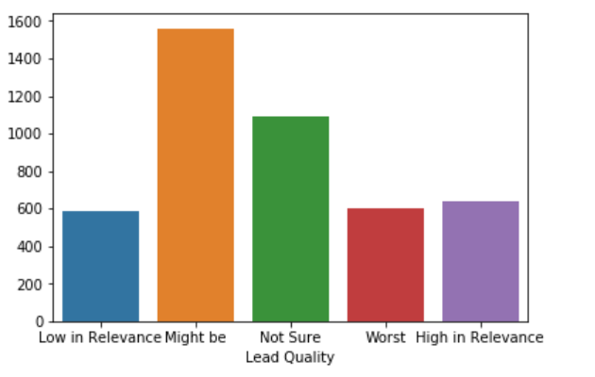

Lead Quality is not a good indicator whether a lead can be converted or not.



**Model Inferences**

Model was built using logistic regression technique. For feature selection, first used RFE and then selected manually. Eventually, we got a mixture of independent features which best explained the model. Final features were:

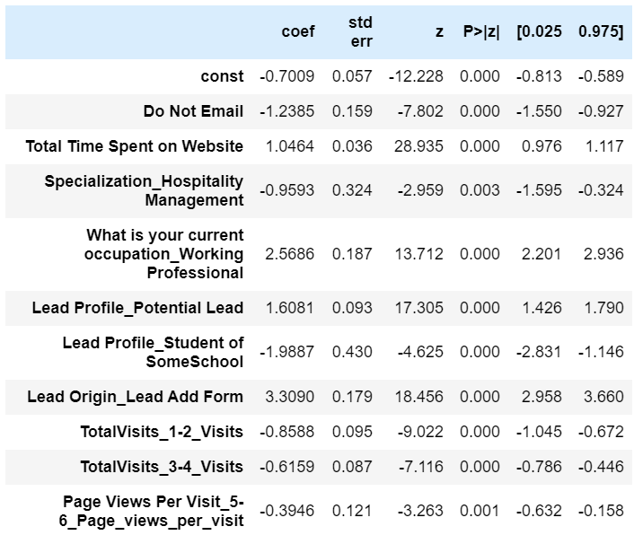

**Assigning lead score**

We moved on to finding the optimal threshold point, which gave us the boundary below above which a lead is taken to be converted or not. Threshold used is: **0.3**

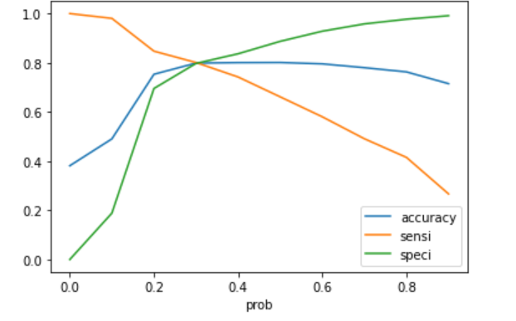

**Metrics**

1. **ROC Curve**

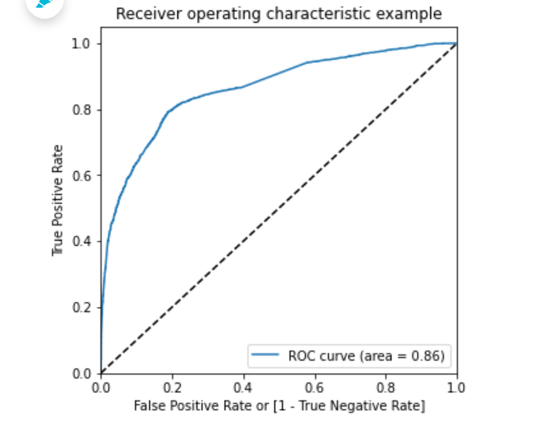

It shows the trade off between sensitivity and specificity

As the curve of the ROC is more towards the upper left corner of the graph, it means the model is very good.

The value of area under the curve is 0.86 which is quite decent.

1. **Precision and Recall Trade off**

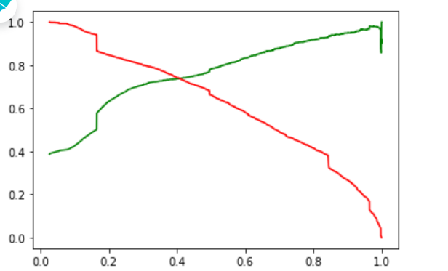

* 1. The recall is bit higher when the precision is high.
  2. Recall is high when precision is low.

1. Model Evaluation on Test Data

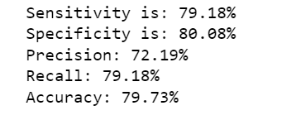

**Important features for good conversion rate**

1. Lead Origin_Lead Add Form
2. What is your current occupation-Working Professional
3. Lead Profile_Student of SomeSchool
4. Lead Profile_Potential Lead